*Florida International University*

*School of Computing and Information Sciences*

Software Engineering Focus

Feature Document

User Story ID 670

**Name:** Account Registration

**Team Member(s):** Leandro Gonzalez,Luis Herrnsdorf

**Project:** Smart Stormwater (Smart City System) 2.0

**Product Owner(s)**: Emilio Lopez

**Mentor(s)**:

**Instructor**: Masoud Sadjadi

**User Story Name:** Account Registration

* Description: As an Admin I want to be able to create new user accounts (regular users or admins) so that I can give access to others

Acceptance Criteria

* The page can be reached on the browser
* Information is sent to the server and it is received
* The registration is done by recording the information to the database
* An ‘OK’ response is sent back if registration goes well, or an error response if it does not
* New users will receive an email with their credentials and a temporary password

**Use Case**

* Name: Add new user
* Actor: Admin, System
* Preconditions: Admin is logged in
* Description: On the main page, the admin clicks on the ‘Users’ tab on the side panel. The admin is redirected to a page with a table listing all of its sub-users, and a plus sign on the top right corner to add new users. The admin clicks on the plus sign and a floating form appears, where the admin inputs the new user’s email, temporary password, role, and department. Admin can click on cancel button and return to sub-users page. If all required fields are provided, admin can click on save button, and the new user will be created. Admin is the redirected to users page, where he/she will now see the new user listed.

**Use Case Diagram**

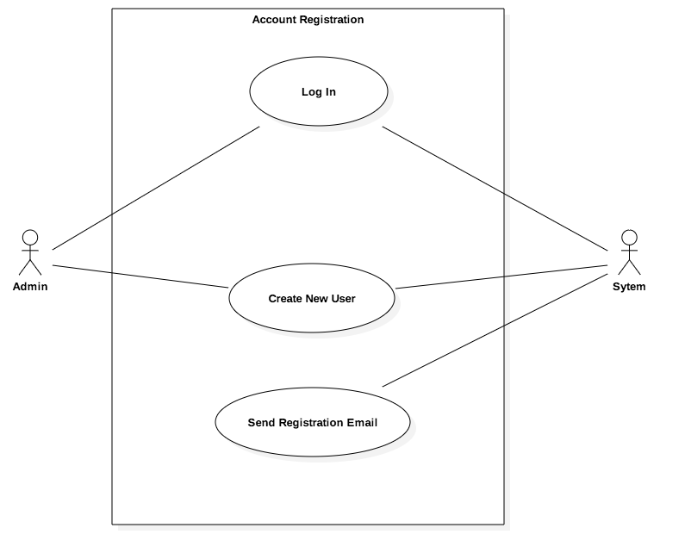

**Sequence Diagram**

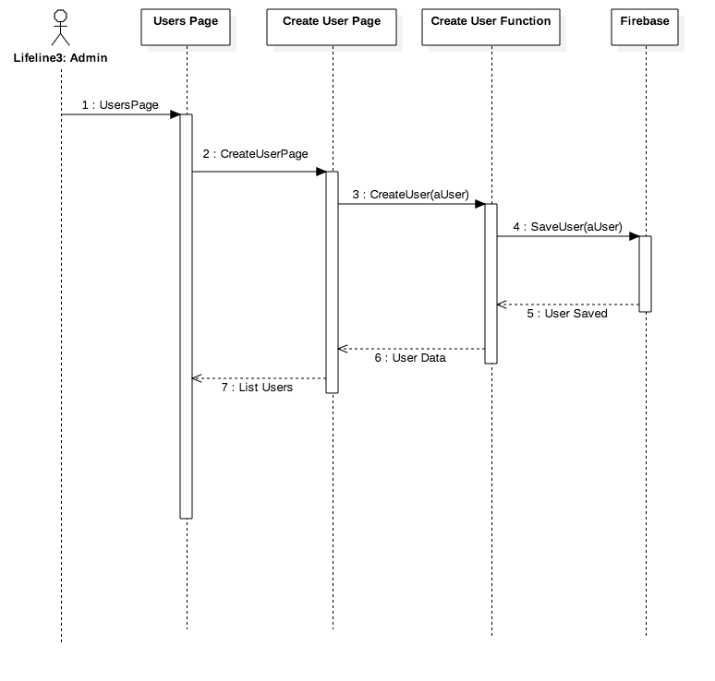

**Class Diagram**

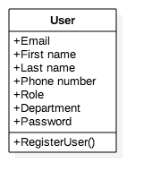

**Unit Test**

* Test case ID: AccountRegistration001
* Description/Summary of Test: Admin creates a new user
* Pre-condition: Email, password, role, and department fields are provided
* Expected Results: New user is created, admin is redirected to sub-users page, new user is listed
* Actual Result: New user was created, admin was redirected to sub-users page, new user was listed
* Status (Fail/Pass): Pass

**Visual User Guide**

